The Hannah FRANCIS
One day event

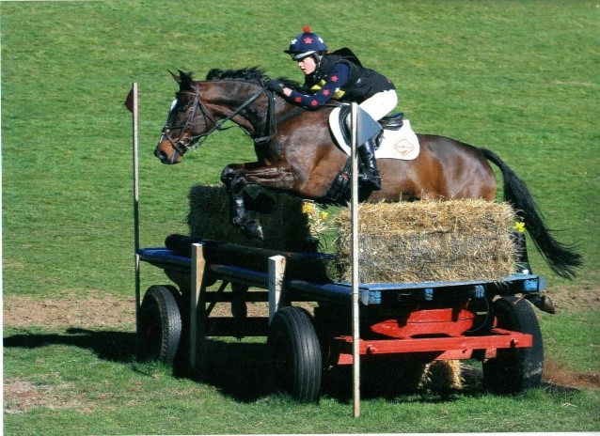

SUNDAY 16TH JULY 2017
at Mendip Plains Equestrian Centre
The Cart House Chewton Field Farm Ston Easton Radstock BA3 4BX
Grid Reference is ST61522580

Unaffiliated but to be run under BE Rules
Open to all – no restrictions on horses with BE points

Refreshments available
Paramedic, Vet and Farrier on Site

We look forward to welcoming you to the Hannah Francis One Day Event. This event is being held to recognise Hannah’s courage, determination and inspiration in her battle with bone cancer, and to celebrate her love of horses, and eventing in particular.
All profits from the event will go to support the work of Hannah’s Willberry Wonder Pony Charity. Registered Charity No 1166416
Online entries www.equoevents.co.uk
Entries Sec Lynda King lyndaking@live.co.uk Email contact preferred - if urgent call 07767 343835
Entry Fee £60 per class (includes medical cover & start fee) Entries will be on a first come first served basis Closing date 3rd July 2017 (or earlier if full) No refund after closing date
Start Times Available Friday 14th July www.equoevents.co.uk
Prizes Rosettes to 10th Place Prizes in kind
Rules All classes will run in accordance with British Eventing rules, except where otherwise stated in this schedule. This means that hats to BE Rule 7.2 must be worn at all times when mounted and Body Protectors to Rule 7.3 must be worn for the XC phase. BE Rules can be found at www.britisheventing.com
It is the competitors responsibility to wear a medical card during the XC phase if they have a medical condition that may impact on their care in the case of an emergency. It is not compulsory for competitors without medical conditions to wear a medical card (BE Rule 9.1)

Class 1: 70cm
Approx height of XC fences 60-70cm (max 70cm) Show jumps maximum height 70cm Dressage Test – BE 95 (2012) Speed 435 mpm
Class 2: 80cm
Approx height of XC fences 70-80cm (max 80cm) Show jumps maximum height 80cm Dressage Test – BE 95 (2012) Speed 435 mpm
Class 3: 90cm
Approx height of XC fences 80-90cm (max 90cm) Show jumps maximum height 90cm Dressage Test – BE 96 (2016) Speed 450 mpm
Course Inspection From 2 pm on Sat 15th July 2017
Order of classes Classes may run in any order. The order in which classes will run will be published online after close of entries.
Numbers Competitors to provide bibs, paper numbers provided
Abandonment If the competition has to be cancelled due to bad weather or other unforeseen circumstances entries will be refunded less a £14 Administration Fee to ensure the Charity does not suffer a loss. Any surplus after unavoidable administration costs have been met will be donated to the Charity

DISCLAIMER
Exception for the negligence of the Organiser and his agents or others for whom in law he is responsible, the Organiser does not accept responsibility in respect of any accident, illness or disease caused to or suffered by any horse, owner, rider, spectator, sponsor and others present at the site of the event and their property and accoutrements.
HEALTH AND SAFETY
The organiser of this event has taken reasonable precautions to ensure the health and safety of everyone present. For these measures to be effective, everyone must take all reasonable precautions to avoid and prevent accidents and must comply with any instructions given by the Organiser, Officials and Stewards.
RESERVATION OF RIGHT
The Organiser has the right to:
- Cancel any class or event
- Divide any class
- Transfer competitors between sections of a class
- Alter the advertised times
- Refuse any entry
TO OUR GUESTS AND MEMBERS OF THE PUBLIC
We hope you will enjoy the Event and for the safety and convenience of competitors ask that you follow a few simple rules:
- Give way to horses at all times
- Dogs to be kept on leads at all times
- Please clear up after your dogs
- Stand well clear from cross country fences and the approach to them, observe the fence judge at each fence and listen for the judge’s whistle as each horse approaches
- Keep your children under strict control
- Use the litter bins provided
Members of the public requiring first aid should go to the secretary’s office.

