How to set up a just giving account

Go to https://home.justgiving.com/
Either sign up (or log in if you have an existing account)

Once you have signed in, click on get started
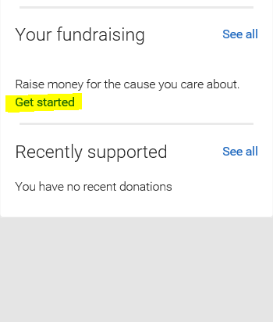

On the next page, select A charity and click on start fundraising

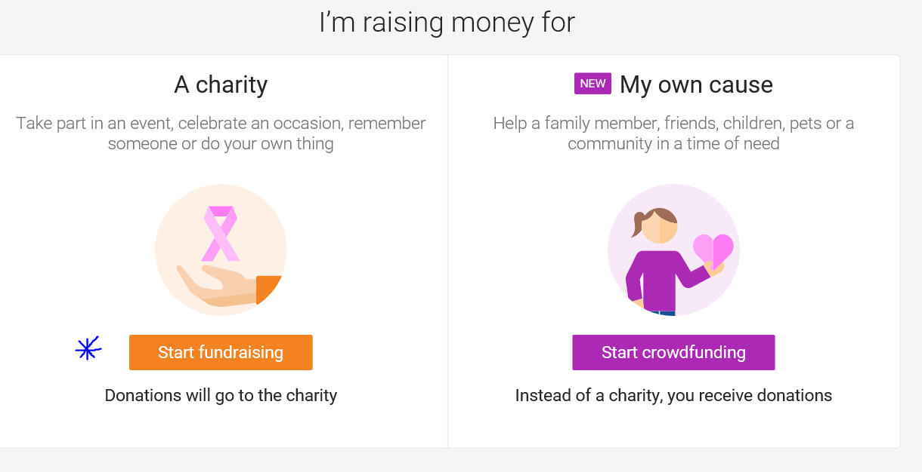

In the search bar to select a charity, type in Willberry Wonder Pony
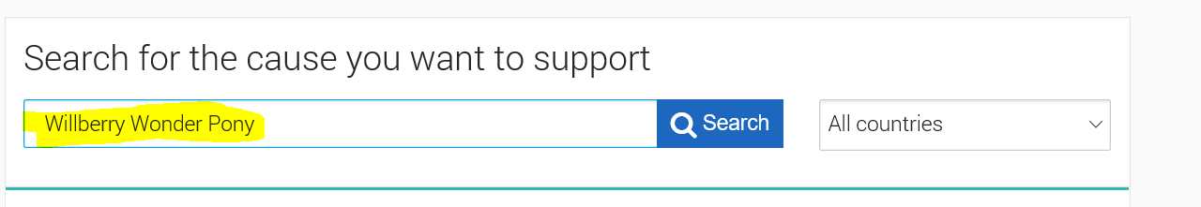

Then click on select
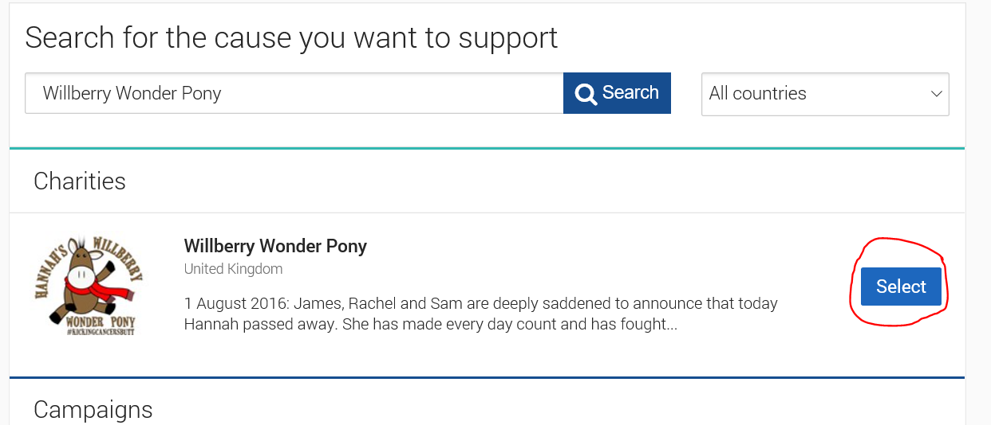

From here, select Personal Challenge
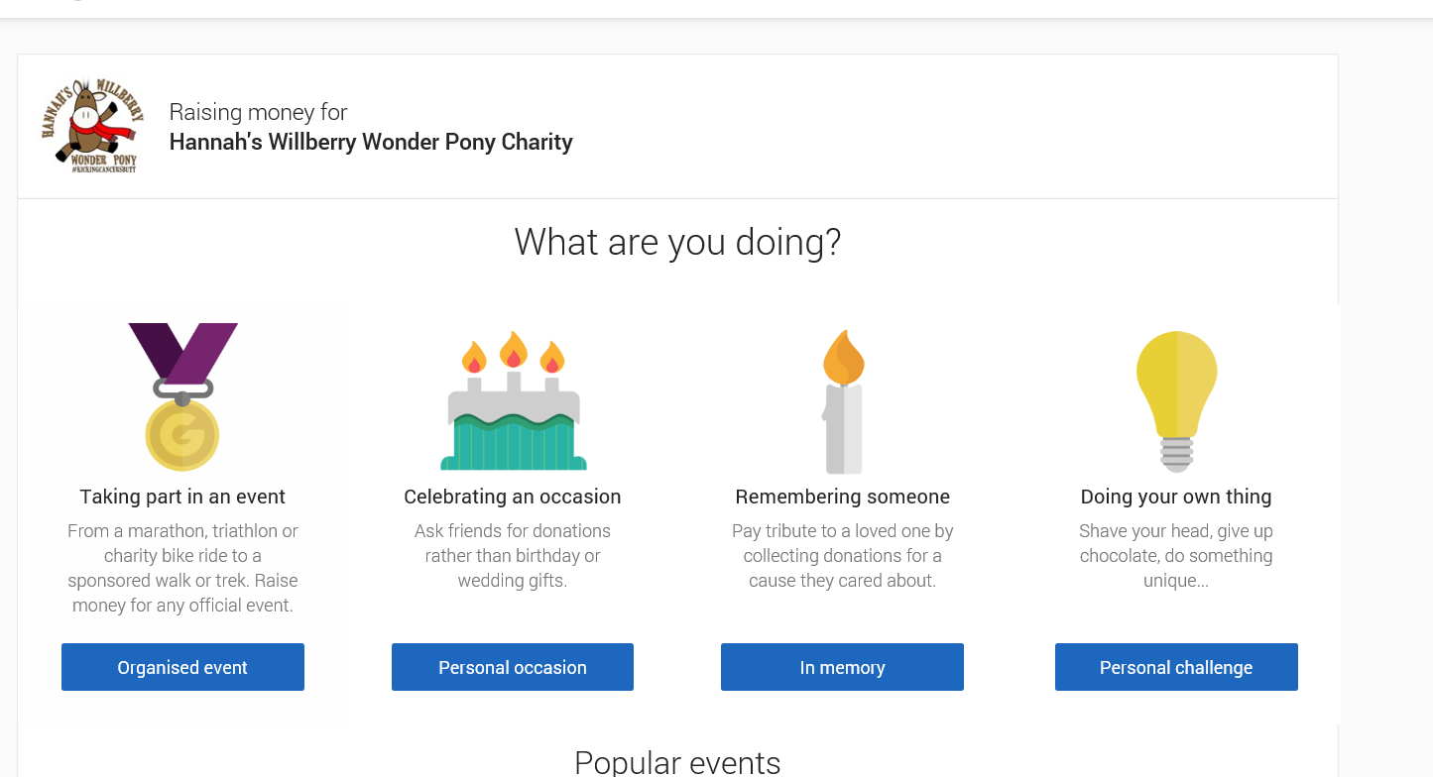

Choose event type and event name as below Wobbleberry Challenge – 7 Goals
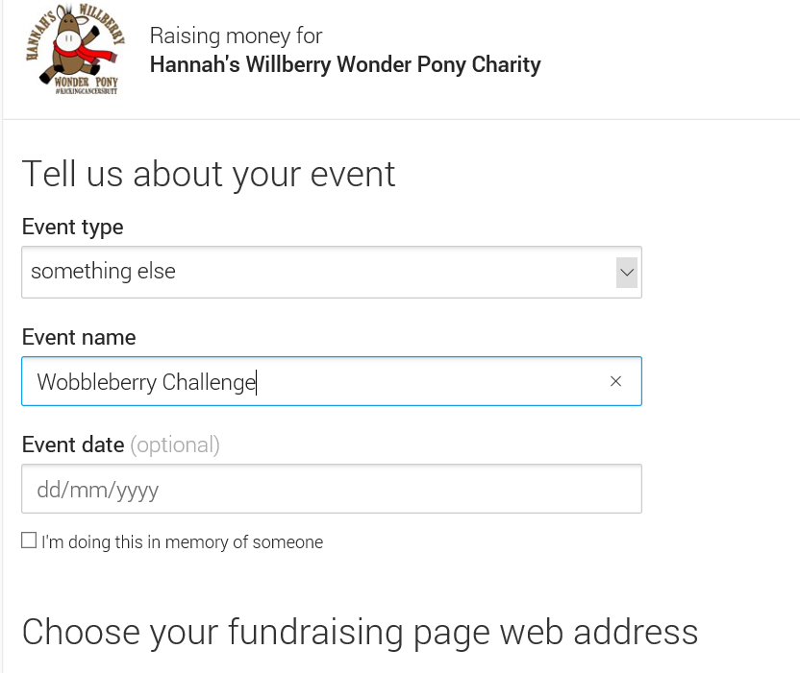
Click

Your page now exists, and is ready for you to add details – you can upload our images, your own images, and tell how this is a challenge for you.

The last step is to join to the team. Once you are logged into your fund raising page, the go to this link

https://www.justgiving.com/teams/wobbleberries

On this page, then click join the team

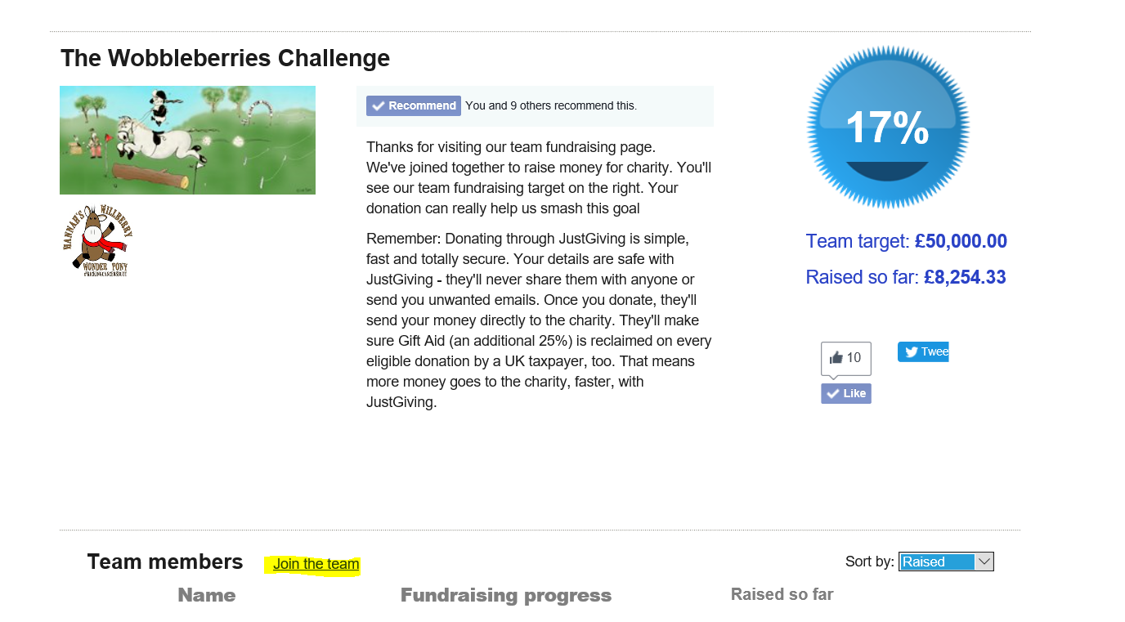

This sends an e mail to us to approve (the e mail takes awhile to come through)
You are good to start raising money as soon as your personal page is set up.
If you have problems joining the team, please send the e mail used in the just giving account to our facebook messages, and we can instead then send you an invite. THANK YOU

